Algorithm for file updates in Python

Project description
In cybersecurity operations, maintaining an accurate IP allow list is essential for ensuring that only authorized systems can connect. Over time, certain IPs must be revoked, and this process can be prone to human error if done manually. To address this, I built a Python algorithm that automatically reads an allow list from a file, removes IPs that appear in a separate remove list, and then rewrites the file with the updated set of addresses. This script demonstrates safe file handling, parsing techniques, iteration and list operations, all of which are highly relevant in security automation.

Open the file that contains the allow list
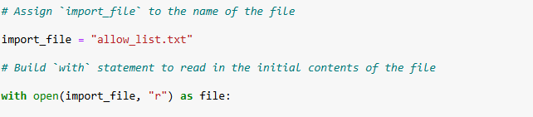
I used the with statement together with the open() function to handle the allow list file. This approach ensures that the file is opened securely and is automatically closed when the block of code completes, even if an error occurs.
The file is opened in “r” (read mode) which allows me to inspect the content without making any changes at this stage. Using “r” explicitly communicates intent: we are entering the data ingestion phase of the workflow. In cybersecurity, proper handling of sensitive files is crucial to avoid corruption, leakage or inconsistent states.

Read the file contents
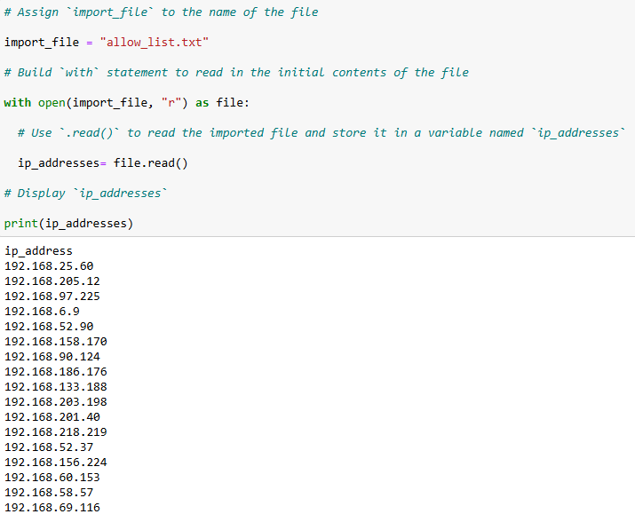
The .read() method loads the entire content of the file into a single string variable called ip_addresses . At this point, the allow list is still unstructured raw text.
By capturing the data into memory, I gain the flexibility to manipulate it with Python’s text-processing functions. This is similar to how security analysts first collect logs of configuration files before parsing them into structured data for deeper analysis.

Convert the string into a list
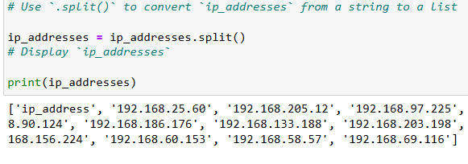
Here i used .split(), this method separates the string wherever it finds whitespace and returns a list of individual elements. In the context of an allow list, this means every IP address becomes a distinct element inside the list.
For verification, I immediately printed the list with print(ip_addresses). This is a good step for debugging practice because it confirms that the text was correctly transformed into a structured list before applying further operations.
In practical terms, this step represents the normalization phase of the workflow: raw text from the file is turned into a list of discrete values.

Iterate through the remove list
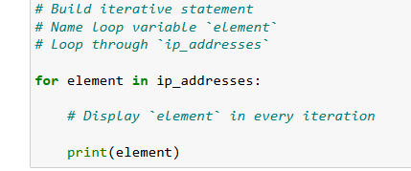
In this part I used a for loop to iterate through every IP address stored in the ip_addresses. The loop sequentially signs each IP to the variable element, allowing me to process them one by one.
The line print(element) is a debugging and validation step. It ensures that the loop is correctly traversing the ip_addresses list and displaying each IP.

Remove IP addresses that are on the remove list
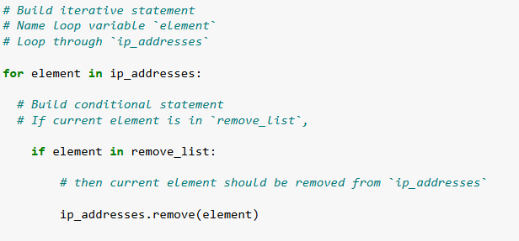
Here, I refined the logic to perform the actual enforcement phase of the algorithm. The for loop iterates through every entry in the current allow list. For each element, the condition if element in remove_list: check whether the IP address is flagged for removal.
If the condition evaluates to true , the method .remove(element) is executed. This operation modifies the list in place by deleting that specific IP from the allow list. Because allow lists are expected to contain unique values, one removal per match is sufficient.

Update the file with the revised list of IP addresses
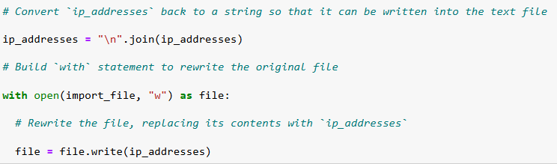
Once the allow list has been cleaned of unauthorized IPs, the next step is to persist the updated data back into the file. I used the string method .join() to convert the list back into a text format. Specifically, “\n”.join(ip_addresses) concatenates the elements of the list into a single string, placing each IP address on a new line. This formatting is critical to maintain the same structure as the original allow list file.
Next, I reopened the file in “w” mode. This mode truncates the file erasing its previous contents and prepares it for new data. Inside the with block I used .write(ip_addresses) to overwrite the file with the revised list. Assigning the result of .write() back to file is not strictly necessary (since .write() returns the number of characters written), but it still works without breaking the logic.
From a cybersecurity perspective this step represents the commit phase of the workflow. The updated allow list is safely written back to disk ensuring that the version used by the system reflects the most current set of approved IP addresses. By automating this write-back process, the algorithm eliminates manual errors and ensures that access policies are consistently enforced.

Summary
In this activity, I developed a Python algorithm to automate the maintenance of an IP allow list. The workflow followed five key phases: opening the file securely with a with open() statement, reading its contents into memory, converting the raw text into a list of IP addresses with .split(), iteration through and removing unauthorized IPs, and finally rewriting the updated allow list back to the file using .join() and .write().

This project demonstrates not only proficiency in Python fundamentals -such as file handling, loops, conditionals, and list operations- but also the ability to apply these techniques in a cybersecurity context. By automating a critical access-control task, the solution reduces human error, enforces policy consistency, and provides a reusable function that can be integrated into larger security workflows.

Overall, this lab reinforced the importance of combining programming best practices with security principles, ensuring that technical implementations remain accurate, efficient, and aligned with organizational security goals.

